MBA Scholarship for Japanese to Study in Hong Kong
香港における日本人対象のMBA奨学金
募 集 概 要

Highlights
The University of Hong Kong (HKU), The Chinese University of Hong Kong (CUHK), and The Hong Kong University of Science and Technology (HKUST) have jointly established a Scholarship expressly to encourage Japanese citizens to study for their MBA degree in Hong Kong and to promote the internationalization of Hong Kong universities. The Scholarship will be awarded to successful applicants who commence their studies during the 2008/09 academic year.

Amount of the Scholarship
An MBA candidate who is awarded the Scholarship will receive up to a maximum of HK$200,000, to be applied to his/her tuition. (Hong Kong $1.0 = Japanese Yen 13.85 as of February 15, 2008)

Eligibility
To qualify applicants must be permanent Japanese citizens who have applied and been admitted to the full-time MBA program offered by HKU, CUHK, and HKUST.

Application Procedures
Completed Scholarship applications should be submitted directly to the Secretariat Office of the MBA Scholarship for Japanese to Study in Hong Kong. Candidates are encouraged to complete and submit their Scholarship applications once they have submitted their MBA application(s) to a respective university. The deadline for Scholarship applications is March 31, 2008.

Application Requirements
Applicants must submit the following:
  - MBA Scholarship for Japanese to Study in Hong Kong Application Form; and
  - Personal Statement: A statement highlighting the applicant’s personal, academic and/or professional accomplishments (max 300 words); and
  - Letter of Recommendation: A letter of reference from an individual who is familiar with the applicant’s professional and/or academic work and suitability to undertake an MBA

The Selection Committee will consider (a) Scholarship application materials (see above); (b) application materials submitted to the MBA Program(s), and (c) the face-to-face interview (for short-listed candidates) in award decisions.

Enquiries: For a Scholarship application form and/or further details, please contact the respective MBA office at a participating university or the Secretariat Office.

Submission: Application materials (Application form, Personal statement, and Letter of recommendation) should be sent by post before March 31, 2008 to:

Secretariat Office, MBA Scholarship for Japanese to Study in Hong Kong
c/o MBA Programmes
The Chinese University of Hong Kong
Shatin, NT, HONG KONG
Telephone: (852) 2609 7786 Fax: (852) 2603 6289 Email: cumba@cuhk.edu.hk
No. _________
 | 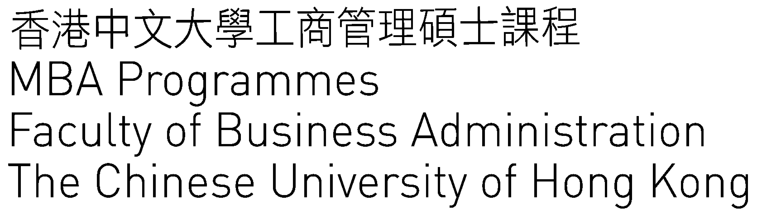   | 

MBA Scholarship for Japanese to Study in Hong Kong 2008/09

Application Form 応募フォーム

The information provided herein will be used for Scholarships/Awards-related purpose. It may be accessible to offices, committees or persons who will process Scholarships/Awards matters.

Part I Personal Particulars

- Personal Data

Family Name |  | Given Name
Japanese Passport No. |  | Gender | Female Male
Home Address
Home/work phone no. |  | Mobile phone no.
Email address

- MBA Program(s) applied and application number

HKU | ( No. ) | CUHK | ( No. ) | HKUST | ( No. )

- Education

 | Name of Institution and Degree |  |  |  |  | Date of Award
1.
2.
3.
- Awards/Academic Distinctions/Scholarships

 | Name of Award |  |  | Academic Year | Amount
1.
2.
3.
- Extra-curricular Activities

 | Post /Contribution | Student Organization/Activities |  |  | Year
1.
2.
3.
- Employment Experience (including part-time and summer employments)

 | Name of Employer |  | Job Title |  |  | Period
1.
2.
3.
Part II Personal Statement

Please provide your personal statement, highlighting your personal, academic and/or professional merits, to qualify for the scholarship (maximum 300 words). Please use a separate page of A4 sized paper and type/print your name on it.

Part III Authorization and Undertaking

I hereby authorize the Secretariat Office to obtain any information from other units of the University which the said Office deems necessary and relevant to the administration and assessment of my application for the captioned award.

I also undertake to inform the Secretariat Office as soon as practicable of any awards/ scholarships/ prizes conferred to me for the academic year 2008/09 after submission of this form.

Signature of Applicant |  |  | Date

Completed form should be sent to

Secretariat Office
MBA Scholarship for Japanese to Study in Hong Kong
c/o MBA Programmes
The Chinese University of Hong Kong
Shatin, NT
HONG KONG

MBA Scholarship for Japanese to Study in Hong Kong 2008/09

Letter of Recommendation
推 薦 状

To the Referee: The MBA Scholarship for Japanese to Study in Hong Kong is offered to permanent Japanese citizens for their study at a Full-time MBA program offered by either the University of Hong Kong, the Hong Kong University of Science and Technology, or The Chinese University of Hong Kong. We appreciate your opinion of this applicant’s potential for success in the MBA study. You may write your letter of recommendation on a separate sheet if necessary. We are grateful for your assistance.

Name of Applicant:

Name of Referee:

1. | How long have you known the applicant and in what capacity?
2. | Please describe this applicant’s strengths.
3. | Why do you believe this applicant deserves this scholarship?

(A separate sheet may be appended, if necessary.)

Signature of Referee |  |  | Date

Referee Information

Name:
Position: |  |  | Institution:
Address:
Phone: |  | Fax: |  | Email:
Relationship with candidate: |  | Employer | Professional | Academic | Others
 |  |  | (please specify: )

Please return this completed form before March 31, 2008 to:
Secretariat Office, MBA Scholarship for Japanese to Study in Hong Kong
c/o MBA Programmes, The Chinese University of Hong Kong, Shatin, NT, HONG KONG

