College Name, Bhopal
Department of Information Technology

Subject: E-Commerce and Governance (Elective-II)
Subject Code: IT-721
Semester: VII

Session: Jul to Dec – 2013

Prepared by:
Prof. rgpvonline.com
Asstt. Prof.
Department of I.T.

Syllabus
Course: E-Commerce and Governance (IT-721)

Unit I:
Introduction to e-commerce: History of e-commerce, e-business models B2B, B2C, C2C, C2B, legal; environment of e-commerce, ethical issues, electronic data interchange, value chain and supply chain, advantages and disadvantages of e-commerce.
Unit II:
Electronic Payment Systems: Credit cards, debit cards, smart cards, e-credit accounts, e-money, Marketing on the web, marketing strategies, advertising on the web, customer service and support, introduction to m-commerce, case study: e-commerce in passenger air transport.
Unit III:
E-Government, theoretical background of e-governance, issues in e-governance applications, evolution of e-governance, its scope and content, benefits and reasons for the introduction of e-governance, e-governance models- broadcasting, critical flow, comparative analysis, mobilization and lobbying, interactive services / G2C2G.
Unit IV:
E-readiness, e-government readiness, E- Framework, step & issues, application of data warehousing and data mining in e-government, Case studies: NICNET-role of nationwide networking in e- governance, e-seva.
Unit V:
E-Government systems security: Challenges and approach to e-government security, security concern in e-commerce, security for server computers, communication channel security, security for client computers.
References:-
- Gary P. Schneider, “E-commerce”, Cengage Learning India.
- C.S.R. Prabhu, “E-governence: concept and case study”, PHI Learning Private Limited.
- V. Rajaraman, “Essentials of E-Commerce Technology”, PHI Learning Private Limited.
UNIT-I
1.1 Introduction to e-commerce: Electronic commerce, commonly known as e-commerce, refers to the buying and selling of products or services over electronic systems such as the Internet and other computer networks. However, the term may refer to more than just buying and selling products online. It also includes the entire online process of developing, marketing, selling, delivering, servicing and paying for products and services. The amount of trade conducted electronically has grown extraordinarily with widespread Internet usage. The use of commerce is conducted in this way, spurring and drawing on innovations in electronic funds transfer, supply chain management, Internet marketing, online transaction processing, electronic data interchange (EDI), inventory management systems, and automated data collection systems. Modern electronic commerce typically uses the World Wide Web at least at one point in the transaction's life-cycle, although it may encompass a wider range of technologies such as e-mail, mobile devices and telephones as well.
A large percentage of electronic commerce is conducted entirely in electronic form for virtual items such as access to premium content on a website, but mostly electronic commerce involves the transportation of physical items in some way. Online retailers are sometimes known as e-tailors and online retail is sometimes known as e-tail. Almost all big retailers are now electronically present on the World Wide Web.
E-commerce is basically the use of the Internet and the Web to transact business. More formally, we focus on digitally enabled commercial transactions between and among organizations and individuals. Each of these components of our working definition of e-commerce is important. Digitally enabled transactions include all transactions mediated by digital technology. For the most part, this means transactions that occur over the Internet and the Web. Commercial transactions involve the exchange of value (e.g., money) across organizational or individual boundaries in return for products and services. Exchange of value is important for understanding the limits of e-commerce. Without an exchange of value, no commerce occurs.
The five general E- Commerce categories are business-to-consumer, business-to-business, business-to-process, consumer-to-consumer, and business-to-government.
Creating an e-commerce solution mainly involves creating and deploying an e-commerce site. The first step in the development of an e-commerce site is to identify the e-commerce model. Depending on the parties involved in the transaction, e-commerce can be classified into four models.

These are:
- Business – to – Business (B2B) model
- Business – to – Consumer (B2C) model
- Consumer – to- Consumer (C2C) model
- Consumer – to – Business (C2B) model

1.2 History of E-commerce: Electronic commerce was identified as the facilitation of commercial transactions electronically, using technology such as Electronic Data Interchange (EDI) and Electronic Funds Transfer (EFT). These were both introduced in the late 1970s, allowing businesses to send commercial documents like purchase orders or invoices electronically. The growth and acceptance of credit cards, automated teller machines (ATM) and telephone banking in the 1980s were also forms of electronic commerce.
From the 1990s onwards, electronic commerce would additionally include enterprise resource planning systems (ERP), data mining and data warehousing. In 1990, Tim Berners-Lee invented the World Wide Web browser and transformed an academic telecommunication network into a worldwide everyman everyday communication system called internet. Commercial enterprise on the Internet was strictly prohibited by NSF until 1995.
Although the Internet became popular worldwide around 1994 with the adoption of Mosaic web browser, it took about five years to introduce security protocols and DSL allowing continual connection to the Internet.
By the end of 2000, many European and American business companies offered their services through the World Wide Web. Since then people began to associate a word "e-commerce" with the ability of purchasing various goods through the Internet using secure protocols and electronic payment services.
The e-commerce revolution is just beginning. For instance:
- Online consumer sales expanded by more than 23% in 2005 to an estimated $142–$172 billion (Shop.org and Forrester Research, 2005).
- The number of individuals online in the United States increased to 175 million in 2005; up from 170 million in 2004 (The total population of the United States is about 300 million.) (U.S. Census Bureau, 2005).
- On an average day, 70 million people go online. Around 140 million send e-mail; 8 million have created a blog, 4 million share music on peer-to-peer networks, and 3 million uses the Internet to rate a person, product, or service (Pew Internet & American Life Project, 2004).
- The number of people who have purchased something online expanded to about 110 million, with additional millions shopping (gathering information) but not purchasing (Pew Research Center, 2005).
It is important to realize that the rapid growth and change that has occurred in the first ten years of e-commerce represents just the beginning: what could be called the first thirty seconds of the e-commerce revolution. The same technologies that drove the first decade of e-commerce continue to evolve at exponential rates. Changes in underlying information technologies and continuing entrepreneurial innovation promise as much change in the next decade as seen in the last decade. The twenty-first century will be the age of a digitally enabled social and commercial life, the outlines of which we can barely perceive at this time. It appears likely that e-commerce will eventually impact nearly all commerce, or that most commerce will be e-commerce by the year 2050.
1.3 E-Commerce Models.

Creating an e-commerce solution mainly involves creating and deploying an e-commerce site. The first step in the development of an e-commerce site is to identify the e-commerce model. Depending on the parties involved in the transaction, e-commerce can be classified into 4 models.

These are:
-  Business – to – Business (B2B) model
- Business – to – Consumer (B2C) model
- Consumer – to- Consumer (C2C) model
- Consumer – to – Business (C2B) model

1.3.1 Business-to-Business (B2B) Model
The B2B model involves electronic transactions for ordering, purchasing, as well as other administrative tasks between houses. It includes trading goods, such as business subscriptions, professional services, manufacturing, and wholesale dealings. Sometimes in the B2B model, business may exist between virtual companies, neither of which may have any physical existence.
In such cases, business is conducted only through the Internet.

Consider a hypothetical example. ABC Company sells automobile parts and XYZ Company assembles this part and then sells the automobile to customers. XYZ Company comes across the Web site of ABC and finds it suitable. XYZ therefore, requests for more information about ABC and finally, decides to purchase automobile parts automobile from ABC. To do this, XYZ places an order on the Web site of ABC. After ABC receives the order details, it validates the information.

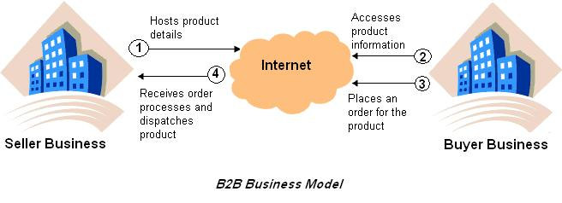

As soon as the order is confirmed, the payment procedures are settled. Finally, ABC sends an
Acknowledgement of payment to XYZ and delivers the goods as per the shipment details decided between the two organizations.

The advantages of the B2B model are:

-  It can efficiently maintain the movement of the supply chain and the manufacturing and procuring processes.
-  It can automate corporate processes to deliver the right products and services quickly and cost-effectively.
- The B2B model is predicted to become the largest value sector of the industry within a few years.
- This is said to be the fastest growing sector of e-commerce.

1.3.2 Business-to-Consumer (B2C) Model

The B2C model involves transactions between business organizations and consumers. It applies to any business organization that sells its products or services to consumers over the Internet. These sites display product information in an online catalog and store it in a database. The B2C model also includes services online banking, travel services, and health information.

Consider a hypothetical example in which a transaction is conducted between a business organization and a consumer. A business house, LMN Department Store, displays and sells a range of products on their Web site. The details information of all their products is contained in the huge catalogs maintained by LMN Department Stores. Now, a consumer, William Ward, wants to buy a gift for his wife. He therefore, logs on to the site of LMN Department Stores and selects a gift from the catalog. He also gets the detailed information about the gift such as, the price, availability, discounts, and so on from their catalog. Finally, when he decides to buy the gift, he places an order for the gift on their Web site. This information is then validated by LMN Department Store and stored in their database. On verification of the information the order is processed. Therefore, as you can see, the B2C model involves transactions between a consumer and one or more business organizations.

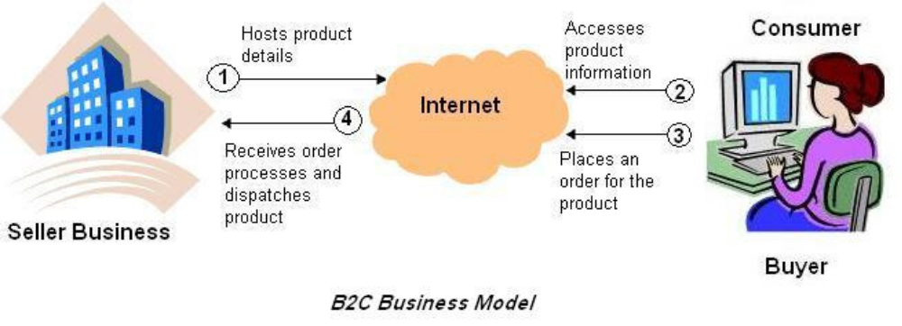

The example of the www.amazon.com site also involves the B2C model in which the consumer searches for a book on their site and places an order, if required. This implies that a complete business solution might be an integration solution of more than one business model. For example, www.amazon.com includes the B2B model in which the publishers transact with Amazon and the B2C model in which an individual consumer transact with the business organization.
The B2C model of e-commerce is more prone to the security threats because individual consumers provide their credit card and personal information n the site of a business organization. In addition, the consumer might doubt that his information is secured and used effectively by the business organization. This is the main reason why the B2C model is not very widely accepted. Therefore, it becomes very essential for the business organizations to provide robust security mechanisms that can guarantee a consumer for securing his information.

1.3.3 Consumer-to-Consumer (C2C) Model

The C2C model involves transaction between consumers. Here, a consumer sells directly to another consumer. Web sites that provide a consumer to advertise and sell their products online to another consumer.
However, it is essential that both the seller and the buyer must register with the auction site. While the seller needs to pay a fixed fee to the online auction house to sell their products, the buyer can bid without paying any fee. The site brings the buyer and seller together to conduct deals.
Let us now look at the previous figure with respect to eBay. When a customer plans to sell his products to other customers on the Web site of eBay, he first needs to interact with an eBay site, which in this case acts as a facilitator of the overall transaction. Then, the seller can host his product on www.ebay.com, which in turn charges him for this.
Any buyer can now browse the site of eBay to search for the product he interested in. If the buyer comes across such a product, he places an order for the same on the Web site of eBay. eBay now purchase the product from the seller and then, sells it to the buyer. In this way, though the transaction is between two customers, an organization acts as an interface between the two organizations.

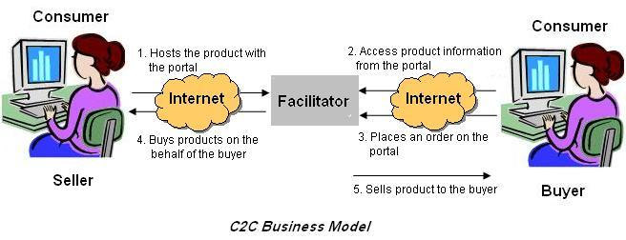

1.3.4 Consumer-to-Business (C2B) Model

The C2B model involves a transaction that is conducted between a consumer and a business organization. It is similar to the B2C model, however, the difference is that in this case the consumer is the seller and the business organization is the buyer. In this kind of a transaction, the consumers decide the price of a particular product rather than the supplier. This category includes individuals who sell products and services to organizations. For example, www.monster.com is a Web site on which a consumer can post his bio-data for the services he can offer. Any business organization that is interested in deploying the services of the consumer can contact him and then employ him, if suitable.

In addition to the models discussed so far, five new models are being worked on that involves transactions between the government and other entities, such as consumer, business organizations, and other governments. All these transactions that involve government as one entity are called e-governance. The various models in the e-governance scenario are:

-  Government-to-Government (G2G) model:
This model involves transactions between 2 governments. For example, if the American government wants to buy oil from the Arabian government, the transaction involved is categorized in the G2G model.
- Government-to-Consumer (G2C) model:
In this model, the government transacts with an individual consumer. For example, a government can enforce laws pertaining to tax payments on individual consumers over the Internet by using the G2C model.
- Consumer-to-Government (C2G) model:
In this model, an individual consumer interacts with the government. For example, a consumer can pay his income tax or house tax online. The transactions involved in this case are C2G transactions.

1.4 Legal: Environment of e-commerce

Businesses that operate on the Web must comply with the same laws and regulations that govern the operations of all businesses. If they do not, they face the same set of penalties—fines, reparation payments, court-imposed dissolution, and even jail time for officers and owners that any business faces.
Businesses operating on the Web face two additional complicating factors as they try to comply with the law. First, the Web extends a company’s reach beyond traditional boundaries. A business that uses the Web immediately becomes an international business. Thus, a company can become subject to many more laws more quickly than a traditional brick-and-mortar business based in one specific physical location.
Second, the Web increases the speed and efficiency of business communications. Customers often have much more interactive and complex relationships with online merchants than they do with traditional merchants. Further, the Web creates a network of customers who often have significant levels of interaction with each other. Web businesses that violate the law or break ethical standards can face rapid and intense reactions from many customers and other stakeholders who become aware of the businesses activities.

1.5Legal and Ethical issues

Borders and Jurisdiction
Territorial borders in the physical world serve a useful purpose in traditional commerce:
They mark the range of culture and reach of applicable laws very clearly. When people travel across international borders, they are made aware of the transition in many ways. For example, exiting one country and entering another usually requires a formal examination of documents, such as passports and visas. In addition, both the language and the currency usually change upon entry into a new country. Each of these experiences, and countless others, are manifestations of the differences in legal rules and cultural customs in the two countries. In the physical world, geographic boundaries almost always coincide with legal and cultural boundaries. The limits of acceptable ethical behavior and the laws that are adopted in a geographic area are the result of the influences of the area’s dominant culture. The relationships among a society’s culture, laws, and ethical standards appear in the geographic boundaries on culture are logical; for most of our history, humans have been unable to travel great distances to learn about other cultures.
In recent years, however, some countries decided that times have indeed changed, and people can travel easily from one country to another within a geographic region. One example is the European Union (EU), which allows free movement within the EU for citizens of member countries.
Most of the EU countries have even formed the European Money Union and use a common currency (the euro) instead of their former individual.
Legal scholars define the relationship between geographic boundaries and legal boundaries in terms of four elements: power, effects, legitimacy, and notice.

Power
Power is a form of control over physical space and the people and objects that reside in that space, and is a defining characteristic of statehood. For laws to be effective, a government must be able to enforce them. Effective enforcement requires the power both to exercise physical control over residents, if necessary, and to impose sanctions on those who violate the law. The ability of a government to exert control over a person or corporation is called jurisdiction.
Laws in the physical world do not apply to people who are not located in or do not own assets in the geographic area that created those particular laws. For example, the United States cannot enforce its copyright laws on a citizen of Japan who is doing business in Japan and owns no assets in the United States. Any assertion of power by the United States over such a Japanese citizen would conflict with the Japanese government’s recognized monopoly on using force with its citizens. Japanese citizens who bring goods into the United States to sell, however, are subject to applicable U.S. copyright laws. A Japanese Web site that offers delivery of goods into the United States is, similarly, subject to applicable U.S. laws.

Effects
Laws in the physical world are grounded in the relationship between physical proximity and the effects, or impact, of a person’s behavior. Personal or corporate actions have stronger effects on people and things that are nearby than on those that are far away.
Government-provided trademark protection is a good example of this. For instance, the Italian government can provide and enforce trademark protection for a business named Casa B located in Rome. The effects of another restaurant using the same name are strongest in Rome, somewhat less in geographic areas close to Rome, and even less in other parts of Italy. That is, the effects diminish as geographic distance increases. If someone were to open a restaurant in Kansas City and call it Casa B, the restaurant in Rome would experience few, if any, negative effects from the use of its trademarked name in Kansas City because it would be so far away and because so few people would be potential customers of both restaurants. Thus, the effects of the trademark violation are controlled by Italian law because of the limited range within which such a violation has an effect.

Jurisdiction on the Internet
Defining, establishing, and asserting jurisdictions are much more difficult on the Internet than they are in the physical world, mainly because traditional geographic boundaries do not exist. For example, a Swedish company that engages in electronic commerce may have a Web site that is entirely in English and a URL that ends in “.com,” thus not indicating to customers that it is a Swedish firm. The server that hosts this company’s Web page could be in Canada, and the people who maintain the Web site might work from their homes in Australia.

If a Mexican citizen buys a product from the Swedish firm and is unhappy with the goods received, that person might want to file a lawsuit against the seller firm. However, the world’s physical border-based systems of law and jurisdiction do not help this Mexican citizen determine where to file the lawsuit. The Internet does not provide anything like the obvious international boundary lines in the physical world. Thus, the four considerations that works so well in the physical world power, effects, legitimacy, and notice, do not translate very well to the virtual world of electronic commerce.

Conflict of Laws
In the United States, business is governed by federal laws, state laws, and local laws. Sometimes, these laws address the same issues in different ways. Lawyers call this situation a conflict of laws. Since online businesses usually serve broad markets that span many localities and many states, they generally look to federal laws for guidance. On occasion, this can lead to problems with state and local laws.
One online business that faced a serious conflict of laws problem was the direct wine sales industry. Most U.S. states have heavily regulated all types of alcoholic beverage sales since the repeal of prohibition in 1933. The U.S. Constitution’s Commerce Clause prohibits the states from passing laws that interfere with interstate commerce. However, the states do have the right to regulate matters pertaining to the health and welfare of their citizens. Under this right, most states have laws that require alcoholic beverages been sold through a regulated system of producers, wholesalers, and retailers. Some states allowed producers (such as wineries) to sell directly to the public, but only within that state. When online wine stores wanted to sell their products across state lines, they ran into these laws. Some states allowed the sales; others allowed the sales if the online store delivered to a licensed retailer in the destination state, and some states prohibited all direct sales. This resulted in a classic conflict of laws. State laws regulated the sale of alcoholic beverages in the interest of the health and welfare of the state’s citizens, yet those same laws gave in-state producers an advantage over out-of-state producers (in some states, in-state producers could sell direct without adding the markup of a retailer; in other states, out-of state producers could not compete at all). When a state law gives an in-state business an advantage over an out-of-state business, the free flow of interstate commerce is impeded and, in general, the U.S. Constitution’s Commerce Clause is violated.

Ethical issues
Companies using Web sites to conduct electronic commerce should adhere to the same ethical standards that other businesses follow. If they do not, they will suffer the same consequences that all companies suffer: the damaged reputation and long-term loss of trust that can result in loss of business. In general, advertising or promotion on the Web should include only true statements and should not omit any information that could mislead potential purchasers or wrongly influence their impressions of a product or service. Even true statements have been held to be misleading when the ad omits important related facts. Any comparisons to other products should be supported by verifiable information. The next section explains the role of ethics in formulating Web business policies, such as those affecting visitors’ privacy rights and companies’ Internet communications with children.

Ethics and Web Business Policies
Web businesses are finding that ethical issues are important to consider when they are making policy decisions. A report of an ethical lapse that is rapidly passed among customers can seriously affect a company’s reputation. In 1999, The New York Times ran a story that disclosed Amazon.com arrangements with publishers for book promotions. Amazon.com was accepting payments of up to $10,000 from publishers to give their books editorial reviews and placement on lists of recommended books as part of a cooperative advertising program. When this news broke, Amazon.com issued a statement that it had done nothing wrong and that such advertising programs were a standard part of publisher-bookstore relationships. The outcry on the Internet in newsgroups and mailing lists was overwhelming. Two days later—before most mass media outlets had even reported the story—Amazon.com announced that it would end the practice and offer unconditional refunds to any customers who had purchased a promoted book. Amazon.com had done nothing illegal, but the practice appeared to be unethical to many of its existing and potential customers.

1.6 Electronic data interchange
Electronic data interchange (EDI) is the structured transmission of data between organizations by electronic means. It is used to transfer electronic documents or business data from one computer system to another computer system, i.e. from one trading partner to another trading partner without human intervention. It is more than mere e-mail; for instance, organizations might replace bills of lading and even cheques with appropriate EDI messages. It also refers specifically to a family of standard.
In 1996, the National Institute of Standards and Technology defined electronic data interchange as "the computer-to-computer interchange of strictly formatted messages that represent documents other than monetary instruments. EDI implies a sequence of messages between two parties, either of whom may serve as originator or recipient.
The formatted data representing the documents may be transmitted from originator to recipient via telecommunications or physically transported on electronic storage media." It distinguishes mere electronic communication or data exchange, specifying that "in EDI, the usual processing of received messages is by computer only.
Human intervention in the processing of a received message is typically intended only for error conditions, for quality review, and for special situations. For example, the transmission of binary or textual data is not EDI as defined here unless the data are treated as one or more data elements of an EDI message and are not normally intended for human interpretation as part of online data processing."
EDI can be formally defined as the transfer of structured data, by agreed message standards, from one computer system to another without human intervention.
EDI is considered to be a technical representation of a business conversation between two entities, either internal or external. Note that there is a perception that "EDI" constitutes the entire electronic data interchange paradigm, including the transmission, message flow, document format, and software used to interpret the documents. EDI is considered to describe the rigorously standardized format of electronic documents. EDI is very useful in supply chain.

1.7 Value chain

The Value Chain concept was developed and popularized in 1985 by Michael Porter, in “Competitive Advantage,” a seminal work on the implementation of competitive strategy to achieve superior business performance. Porter defined value as the amount buyers are willing to pay for what a firm provides, and he conceived the “value chain” as the combination of nine generic value added activities operating within a firm – activities that work together to provide value to customers. Porter linked up the value chains between firms to form what he called a Value System; however, in the present era of greater outsourcing and collaboration the linkage between multiple firms’ value creating processes has more commonly become called the “value chain.” As this name implies, the primary focus in value chains is on the benefits that accrue to customers, the interdependent processes that generate value, and the resulting demand and funds flows that are created.

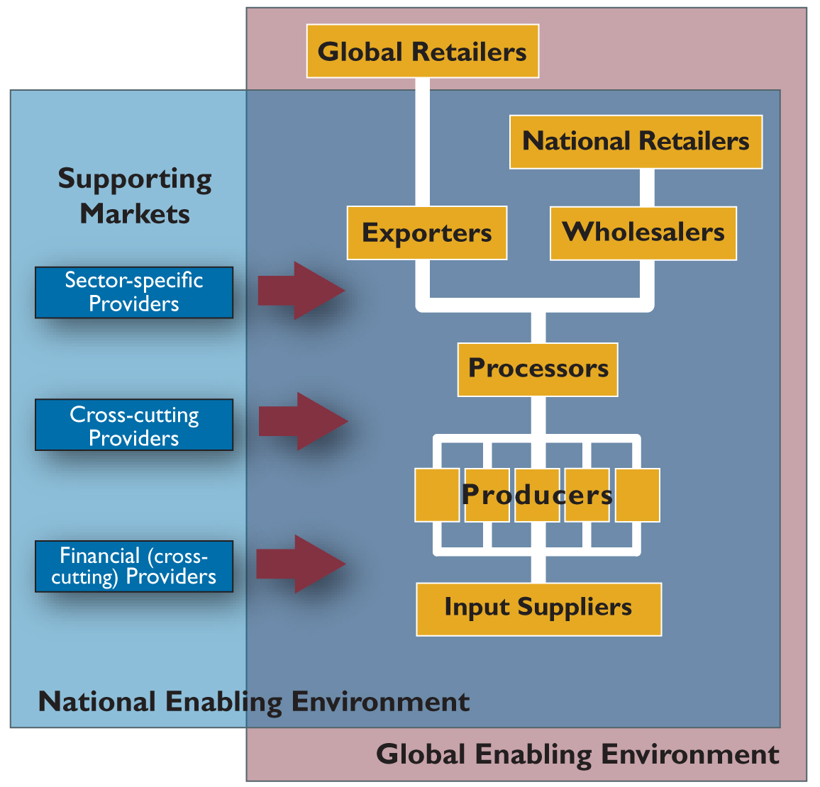
Example of Value Chain

Effective value chains generate profits. To bring the concept of value into focus, consider for a moment a person walking in the desert, a person who is dying of thirst. As that person walks they have one thing on their mind, and that is water. At that moment there is little consideration for the form of the water, the container, or who will be providing it. Water has a unique value to that person. When they find water, or they are offered some, money would be of little concern. What is the point of this example? First is that value is a subjective experience that is dependent on context. In the context of a busboy clearing a table, a glass of water sitting there has no value, or even negative value – it’s just more work for him. But for the man dying of thirst, that same glass of water is extremely valuable. Second, value occurs when needs are met through the provision of products, resources, or services – usually during some form of transaction or exchange. Finally, value is an experience, and it flows from the person (or institution) that is the recipient of resources – it flows from the customer. This is a key difference between a value chain and a supply chain – they flow in opposite directions. Many views of Value Chains can be created. Examples of Value Chains are
• One that takes an order from a customer
• One that fulfills a customer requirement
• One that defines a product or service.

1.8 Supply Chain

A supply chain is a system of organizations, people, technology, activities, information and resources involved in moving a product or service from supplier to customer. Supply chain activities transform natural resources, raw materials and components into a finished product that is delivered to the end customer. In sophisticated supply chain systems, used products may re-enter the supply chain at any point where residual value is recyclable. Supply chains link value chains.

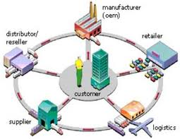

Example of Supply Chain

The Council of Supply Chain Management Professionals (CSCMP) defines supply chain management as follows: “Supply Chain Management encompasses the planning and management of all activities involved in sourcing and procurement, conversion, and all logistics management activities. Importantly, it also includes coordination and collaboration with channel partners, which can be suppliers, intermediaries, third-party service providers, and customers. In essence, supply chain management integrates supply and demand management within and across companies. Supply Chain Management is an integrating function with primary responsibility for linking major business functions and business processes within and across companies into a cohesive and high-performing business model. It includes all of the logistics management activities noted above, as well as manufacturing operations, and it drives coordination of processes and activities with and across marketing, sales, product design, finance and information technology.”
A typical supply chain begins with ecological and biological and political regulation of natural resources, followed by the human extraction of raw material, and includes several production links before moving on to several layers of storage facilities of ever-decreasing size and ever more remote geographical locations, and finally reaching the consumer.
There are a variety of supply chain models, which address both the upstream and downstream sides. However the SCOR model is most common.
The SCOR Supply-Chain Operations Reference model, developed by the Supply Chain Council, measures total supply chain performance. It is a process reference model for supply-chain management, spanning from the supplier's supplier to the customer's customer.^{[3]} It includes delivery and order fulfillment performance, production flexibility, warranty and returns processing costs, inventory and asset turns, and other factors in evaluating the overall effective performance of a supply chain.
1.9 Advantages of E-commerce

- Lower Cost
Doing e-business is cost effective; it reduces logistical problems and puts a small business on a par with giants such as Amazon.com or General Motors. In a commercial bank, for example. a basic over-the-counter transaction costs £0.50 to process; over the Internet, the same transaction costs about £0.01. Every financial transaction eventually turns into an electronic process. The sooner it makes the conversion, the more cost-effective the transaction becomes.
- Economy
Unlike the brick–and–mortar environment, in e–commerce there is no physical store space, insurance, or infrastructure investment. All you need is an idea, a unique product, and a well–designed web storefront to reach your customers, plus a partner to do fulfillment. This makes e–commerce a lot more economical.
- Higher Margins
E–commerce means higher margins. For example, the cost of processing an airline ticket is £5. According to one travel agency, processing the same ticket online costs £1. Along with higher margins, businesses can gain more control and flexibility and are able to save time when manual transactions are done electronically.
- Better Customer Service
E–commerce means better and quicker customer service. Online customer service makes customers happier. Instead of calling your company on the phone, the web merchant gives customers direct to their personal account online. This saves time and money. For companies that do business with other companies, adding customer service online is a competitive advantage. The overnight package delivery service, where tracking numbers allow customers to check the whereabouts of a package online, is one good example.
- Quick Comparison Shopping
E–commerce helps consumers to comparison shop. Automated online shopping assistants called hop bots scour online stores and find deals on everything from apples ro printer ribbons.
- Productivity Gains
Weaving the web throughout an organization means improved productivity. For example IBM incorporated the web into every corner of the firm – products, marketing, and practices. The company figured it would save $750 million by letting customers find answers to technical questions via its website. The total cost savings in 1999 alone was close to $1 billion.
- Teamwork
E–mail is one example of how people collaborate to exchange information and work on solutions. It has transformed the way organizations interact with suppliers, vendors, business partners, and customers. More interactions mean better results.

- Knowledge Markets
E–commerce helps create knowledge markets. Small groups inside big firms can be funded with seed money to develop new ideas. For example, DaimlerChrysler has created small teams to look for new trends and products. A Silicon Valley team is doing consumer research on electric cars and advising car designers.
- Information Sharing, Convenience, And Control
Electronic marketplaces improve information sharing between merchants and customers and promote quick, just–in–time deliveries. Convenience for the consumer is a major driver for changes in various industries. Customers and merchants save money; are online 24 hours a day, 7 days a week; experience no traffic jams, no crowds, and do not have to carry heavy shopping bags.

1.9.1 Disadvantages of E–commerce
- Security
Security continues to be a problem for online businesses. Customers have to feel confident about the integrity of the payment process before they commit to the purchase.
- System And Data Integrity
Data protection and the integrity of the system that handles the data are serious concerns. Computer viruses are rampant, with new viruses discovered every day. Viruses cause unnecessary delays, file backups, storage problems, and other similar difficulties. The danger of hackers accessing files and corrupting accounts adds more stress to an already complex operation.
- System Scalability
A business develops an interactive interface with customers via a website. After a while, statistical analysis determines whether visitors to the site are one–time or recurring customers. If the company expects 2 million customers and 6 million shows up, website performance is bound to experience degradation, slowdown, and eventually loss of customers. To stop this problem from happening, a website must be scalable, or upgradable on a regular basis.
- E–commerce Is Not Free
So far, success stories in e–commerce have forced large business with deep pockets and good funding. According to a report, small retailers that go head–to–head with e–commerce giants are fighting losing battle. As in the brick–and–mortar environment, they simply cannot compete on price or product offering. Brand loyalty is related to this issue, which is supposed to be less important for online firms. Brands are expected to lower search costs, build trust, and communicate quality. A search engine can come up with the best music deals, for example, yet consumers continue to flock to trusted entities such as HMV.
- Consumer Search Is Not Efficient or Cost–effective
On the surface, the electronic marketplace seems to be a perfect market, where worldwide sellers and buyers share and trade without intermediaries. However, a closer look indicates that new types of intermediaries are essential to e–commerce. They include electronic malls that guarantee legitimacy of transactions. All these intermediaries add to transaction costs.
- Customer Relations Problems
Not many businesses realize that even e–business cannot survive over the long term without loyal customers.
- Products People won't buy online
Imagine a website called furniture.com or living.com, where venture capitalists are investing millions in selling home furnishings online. In the case of a sofa, you would want to sit on it, feel the texture of the fabric etc. Beside the sofa test, online furniture stores face costly returns which make the product harder to sell online.
- Corporate Vulnerability
The availability of product details, catalogs, and other information about a business through its website makes it vulnerable to access by the competition. The idea of extracting business intelligence from the website is called web framing.
- High Risk Of Internet Start–up
Many stories unfolded in 1999 about successful executives in established firms leaving for Internet start–ups, only to find out that their get–rich dream with a dot.com was just that – a dream.

*******

UNIT-II
2.1 Electronic Payment Systems

An e-commerce payment system facilitates the acceptance of electronic payment for online transactions. Also known as a sample of Electronic Data Interchange (EDI), e-commerce payment systems have become increasingly popular due to the widespread use of the internet-based shopping and banking.

Over the years, credit cards have become one of the most common forms of payment for e-commerce transactions. In North America almost 90% of online B2C transactions were made with this payment type. Turban et al. goes on to explain that it would be difficult for an online retailer to operate without supporting credit and debit cards due to their widespread use.

Increased security measures include use of the card verification number (CVN) which detects fraud by comparing the verification number printed on the signature strip on the back of the card with the information on file with the cardholder's issuing bank. Also online merchants have to comply with stringent rules stipulated by the credit and debit card issuers (Visa and MasterCard) this means that merchants must have security protocol and procedures in place to ensure transactions are more secure. This can also include having a certificate from an authorized certification authority (CA) who provides PKI infrastructure for securing credit and debit card transactions.
Despite oshen this widespread use in North America, there are still a large number of countries such as China, India and Pakistan that have some problems to overcome in regard to credit card security. In the meantime, the use of smartcards has become extremely popular.

A Smartcard is similar to a credit card; however it contains an embedded 8-bit microprocessor and uses electronic cash which transfers from the consumers’ card to the sellers’ device. A popular smartcard initiative is the VISA Smartcard. Using the VISA Smartcard you can transfer electronic cash to your card from your bank account, and you can then use your card at various retailers and on the internet.

Electronic payment systems and in particular, methods of payment being developed to support Internet based commerce cannot be examined in isolation.

A failure to place these developments into proper context is likely to result in undue focus on the various experimental initiatives to develop electronic forms of payment without proper reflection on the broader implications for the existing payment systems.

The reality of the current UK payment system is that it is primarily paper based with more than 80 % of all individual payment transactions taking the form of cash payments, cheques or other paper credits.

The majority of individual payment transactions involve goods and services being exchanged for cash that are made face to face, i.e. both buyer and seller are physically present.

2.1.1 Credit Card
A credit card is a payment card issued to users as a system of payment. It allows the cardholder to pay for goods and services based on the holder's promise to pay for them. The issuer of the card creates a revolving account and grants a line of credit to the consumer (or the user) from which the user can borrow money for payment to a merchant or as a cash advance to the user.
A credit card is different from a charge card: a charge card requires the balance to be paid in full each month. In contrast, credit cards allow the consumers a continuing balance of debt, subject to interest being charged. A credit card also differs from a cash card, which can be used like currency by the owner of the card.
Credit cards are issued by a credit card issuer, such as a bank or credit union, after an account has been approved by the credit provider, after which cardholders can use it to make purchases at merchants accepting that card. Merchants often advertise which cards they accept by displaying acceptance marks – generally derived from logos – or may communicate this orally, as in "We take (brands X, Y, and Z)" or "We don't take credit cards".
When a purchase is made, the credit card user agrees to pay the card issuer. The cardholder indicates consent to pay by signing a receipt with a record of the card details and indicating the amount to be paid or by entering a personal identification number (PIN). Also, many merchants now accept verbal authorizations via telephone and electronic authorization using the Internet, known as a card not present transaction (CNP).
Electronic verification systems allow merchants to verify in a few seconds that the card is valid and the credit card customer has sufficient credit to cover the purchase, allowing the verification to happen at time of purchase. The verification is performed using a credit card payment terminal or point-of-sale (POS) system with a communications link to the merchant's acquiring bank. Data from the card is obtained from a magnetic stripe or chip on the card; the latter system is called Chip and PIN in the United Kingdom and Ireland, and is implemented as an EMV card.
2.1.2 Debit Card
A debit card (also known as a bank card or check card) is a plastic card that provides the cardholder electronic access to his or her bank account(s) at a financial institution. Some cards have a stored value with which a payment is made, while most relay a message to the cardholder's bank to withdraw funds from a designated account in favor of the payee's designated bank account. The card can be used as an alternative payment method to cash when making purchases. In some cases, the primary account number is assigned exclusively for use on the Internet and there is no physical card.
In many countries, the use of debit cards has become so widespread that their volume has overtaken or entirely replaced cheques and, in some instances, cash transactions. The development of debit cards, unlike credit cards and charge cards, has generally been country specific resulting in a number of different systems around the world, which were often incompatible. Since the mid 2000s, a number of initiatives have allowed debit cards issued in one country to be used in other countries and allowed their use for internet and phone purchases.
Unlike credit and charge cards, payments using a debit card are immediately transferred from the cardholder's designated bank account, instead of them paying the money back at a later date.
Debit cards usually also allow for instant withdrawal of cash, acting as the ATM card for withdrawing cash. Merchants may also offer cash back facilities to customers, where a customer can withdraw cash along with their purchase.
2.1.3 Smart Cards
A smart card, chip card, or integrated circuit card (ICC) is any pocket-sized card with embedded integrated circuits. Smart cards are made of plastic, generally polyvinyl chloride, but sometimes acrylonitrile butadiene styrene or polycarbonate.
Smart cards can provide identification, authentication, data storage and application processing. Smart cards may provide strong security authentication for single sign-on (SSO) within large organizations.
Smart cards serve as credit or ATM cards, fuel cards, mobile phone SIMs, authorization cards for pay television, household utility pre-payment cards, high-security identification and access-control cards, and public transport and public phone payment cards.
Smart cards may also be used as electronic wallets. The smart card chip can be "loaded" with funds to pay parking meters and vending machines or at various merchants. Cryptographic protocols protect the exchange of money between the smart card and the accepting machine. No connection to the issuing bank is necessary, so the holder of the card can use it even if not the Contactless smart cards that do not require physical contact between card and reader are becoming increasingly popular for payment and ticketing applications such as mass transit and motorway tolls.
2.1.4 E-commerce credit card payment system
Electronic commerce, commonly known as e-commerce, or e-business consists of the buying and selling of products or services over electronic systems such as the Internet and other computer networks. The amount of trade conducted electronically has grown extraordinarily with widespread Internet usage. The use of commerce is conducted in this way, spurring and drawing on innovations in electronic funds transfer, supply chain management, Internet marketing, online transaction processing, electronic data interchange (EDI), inventory management systems, and automated data collection systems. Modern electronic commerce typically uses the World Wide Web at least at some point in the transaction's lifecycle, although it can encompass a wider range of technologies such as e-mail as well.
A large percentage of electronic commerce is conducted entirely electronically for virtual items such as access to premium content on a website, but most electronic commerce involves the transportation of physical items in some way. Online retailers are sometimes known as e-tailers and online retail is sometimes known as e-tail. Almost all big retailers have electronic commerce presence on the World Wide Web.

2.1.5 Electronic money
Electronic money (also known as e-currency, e-money, electronic cash, electronic currency, digital money, digital cash, digital currency, cyber currency) is money or scrip that is only exchanged electronically. Typically, this involves the use of computer networks, the internet and digital stored value systems. Electronic funds transfer (EFT), direct deposit, digital gold currency and virtual currency are all examples of electronic money. Also, it is a collective term for financial cryptography and technologies enabling it.
While electronic money has been an interesting problem for cryptography, the use of e-money has been relatively low-scale. One rare success has been Hong Kong's Octopus card system, which started as a transit payment system and has grown into a widely used electronic money system. London Transport's Oyster card system remains essentially a contactless pre-paid travelcard. Two other cities have implemented functioning electronic money systems. Very similar to Hong Kong's Octopus card, Singapore has an electronic money program for its public transportation system (commuter trains, bus, etc.), based on the same type of (FeliCa) system. The Netherlands has also implemented a nationwide electronic money system known as Chipknip for general purpose, as well as OV-Chipkaart for transit fare collection. In Belgium, a payment service company, Proton, owned by 60 Belgian banks issuing stored value cards, was developed in 1995.
A number of electronic money systems use contactless payment transfer in order to facilitate easy payment and give the payee more confidence in not letting go of their electronic wallet during the transaction.
2.2 Marketing on the web
Marketing on the web is referred to as the marketing (generally promotion) of products or services over the Internet. Internet marketing is considered to be broad in scope because it not only refers to marketing on the Internet, but also includes marketing done via e-mail and wireless media. Digital customer data and electronic customer relationship management (ECRM) systems are also often grouped together under internet marketing.
Marketing on the Web is an old game with new rules. It's a world of alliances, banner ads, e-mail marketing, and search engine techniques. If you're a savvy online marketer, you understand and incorporate these new tactics as you develop a marketing strategy to reach your target audience. Otherwise, your site will struggle in cyberspace.

Internet marketing is inexpensive when examining the ratio of cost to the reach of the target audience. Companies can reach a wide audience for a small fraction of traditional advertising budgets. The nature of the medium allows consumers to research and to purchase products and services conveniently. Therefore, businesses have the advantage of appealing to consumers in a medium that can bring results quickly. The strategy and overall effectiveness of marketing campaigns depend on business goals and cost-volume-profit (CVP) analysis.

Internet marketers also have the advantage of measuring statistics easily and inexpensively; almost all aspects of an Internet marketing campaign can be traced, measured, and tested, in many cases through the use of an ad server. The advertisers can use a variety of methods, such as pay per impression, pay per click, pay per play, and pay per action. Therefore, marketers can determine which messages or offerings are more appealing to the audience. The results of campaigns can be measured and tracked immediately because online marketing initiatives usually require users to click on an advertisement, to visit a website, and to perform a targeted action.

2.3 Marketing Strategies

Marketing strategy is a process that can allow an organization to concentrate its limited resources on the greatest opportunities to increase sales and achieve a sustainable competitive advantage.
Marketing strategies serve as the fundamental underpinning of marketing plans designed to fill market needs and reach marketing objectives. Plans and objectives are generally tested for measurable results. Commonly, marketing strategies are developed as multi-year plans, with a tactical plan detailing specific actions to be accomplished in the current year.
Marketing strategies are dynamic and interactive. They are partially planned and partially unplanned.

Marketing Strategies
Marketing strategy involves careful scanning of the internal and external environments. Internal environmental factors include the marketing mix, plus performance analysis and strategic constraints. External environmental factors include customer analysis, competitor analysis, target market analysis, as well as evaluation of any elements of the technological, economic, cultural or political/legal environment likely to impact success. A key component of marketing strategy is often to keep marketing in line with a company's overarching mission statement.
Once a thorough environmental scan is complete, a strategic plan can be constructed to identify business alternatives, establish challenging goals, determine the optimal marketing mix to attain these goals, and detail implementation. A final step in developing a marketing strategy is to create a plan to monitor progress and a set of contingencies if problems arise in the implementation of the plan.
2.4 Advertising on the Web

Advertising on the web is a form of promotion that uses the Internet and World Wide Web to deliver marketing messages to attract customers. Examples of online advertising include contextual ads on search engine results pages, banner ads, blogs, Rich Media Ads, Social network advertising, interstitial ads, online classified advertising, advertising networks and e-mail marketing, including e-mail spam. Many of these types of ads are delivered by an Ad server.
One major benefit of online advertising is the immediate publishing of information and content that is not limited by geography or time. To that end, the emerging area of interactive advertising presents fresh challenges for advertisers who have hitherto adopted an interruptive strategy.
Another benefit is the efficiency of the advertiser's investment. Online advertising allows for the customization of advertisements, including content and posted websites. For example, Ad Words, Yahoo! Search Marketing and Google Ad Sense enable ads to be shown on relevant web pages or alongside search results.
The internet has become an ongoing emerging source that tends to expand more and more. The growth of this particular medium attracts the attention of advertisers as a more productive source to bring in consumers.
A clear advantage consumers have with online advertisement is the control they have over the product, choosing whether to check it out or not.
Online advertisements may also offer various forms of animation. In its most common use, the term "online advertising" comprises all sorts of banner, e-mail, in-game, and keyword advertising, including on platforms such as Face book, Twitter, and MySpace. Research has proven that online advertising has given results and is growing business revenue.

2.5 Customer service and support
Customer service is the provision of service to customers before, during and after a purchase. "Customer service is a series of activities designed to enhance the level of customer satisfaction that is, the feeling that a product or service has met the customer expectation."
Its importance varies by products, industry and customer; defective or broken merchandise can be exchanged, often only with a receipt and within a specified time frame. Retail stores often have a desk or counter devoted to dealing with returns, exchanges and complaints, or will perform related functions at the point of sale; the perceived success of such interactions being dependent on employees "who can adjust themselves to the personality of the guest,".
From the point of view of an overall sales process engineering effort, customer service plays an important role in an organization's ability to generate income and revenue. From that perspective, customer service should be included as part of an overall approach to systematic improvement. A customer service experience can change the entire perception a customer has of the organization.
2.6 Introduction to m-commerce
Mobile Commerce, also known as m-commerce, is the ability to conduct commerce using a mobile device, such as a mobile phone, a Personal Digital Assistant (PDA), a Smartphone, or other emerging mobile equipment such as desktop mobile devices. Mobile Commerce has been defined as follows:
"Mobile Commerce is any transaction, involving the transfer of ownership or rights to use goods and services, which is initiated and/or completed by using mobile access to computer-mediated networks with the help of an electronic device."
According to comScore, up to November 2011 there were 38 percent of Smartphone owners have used their phone to make a purchase at least once.
Mobile commerce was born in 1997 when the first two mobile-phones enabled Coca Cola vending machines were installed in the Helsinki area in Finland. The machines accepted payment via SMS text messages. The first mobile phone-based banking service was launched in 1997 by Merita Bank of Finland, also using SMS.
In 1998, the first sales of digital content as downloads to mobile phones were made possible. With the introduction of mobile money services for the unbanked, operators are now looking for efficient ways to roll out and manage distribution networks that can support cash-in and cash-out.

Mobile ticketing
Tickets can be sent to mobile phones using a variety of technologies. Users are then able to use their tickets immediately, by presenting their phones at the venue.
Tickets can be booked and cancelled on the mobile device with the help of simple application downloads, or by accessing the WAP portals of various travel agents or direct service providers.

Mobile vouchers, coupons and loyalty cards
Mobile ticketing technology can also be used for the distribution of vouchers, coupons, and loyalty cards. These items are represented by a virtual token that is sent to the mobile phone. A customer presenting a mobile phone with one of these tokens at the point of sale receives the same benefits as if they had the traditional token. Stores may send coupons to customers using location-based services to determine when the customer is nearby.

Content purchase and delivery
Currently, mobile content purchase and delivery mainly consists of the sale of ring-tones, wallpapers, and games for mobile phones. The convergence of mobile phones, portable audio players, and video players into a single device is increasing the purchase and delivery of full-length music tracks and video. The download speeds available with 4G networks make it possible to buy a movie on a mobile device in a couple of seconds.
2.7 Case study: e-commerce in passenger air transport

When a customer makes a flight reservation a unique “passenger name record” (PNR) is created, which contains flight information and personal details of the person flying. If a car is hired or a hotel is booked at the same time, this information will also be stored on the PNR.

Few airlines store these records on their own system, but instead subscribe to a “global distribution system” (GDS), which is an organization that stores flight details and PNRs for several airlines on its databases.

Various sources contribute to a PNR record

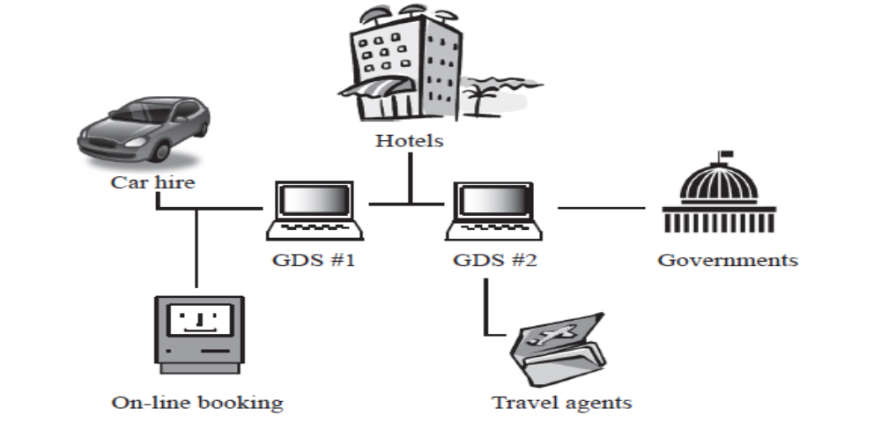

At present, there are four major GDSs: Amadeus, Galileo, Sabre and Wordspan. Travel agents are connected to these GDSs through Wide Area Networks. These GDSs use a similar format for their records so that information can be passed between them. This allows computerized reservation systems to book flights using one or more airlines with minimal delay.

In recent years, certain governments have requested that more detailed personal information is added to a PNR. Agreement has been reached, to the alarm of human rights organizations, that the information on these records can be accessed by governments and used to fight certain serious crimes.
A PNR could, therefore, contain credit card details, addresses, phone numbers, emergency contacts, information on people who travel together, personal preferences (such as meal choices), details of medical conditions and so on.

Each flight is automatically categorized as either arrival or departure, and included on the appropriate set of pages with a choice of arrivals or departures on each individual public screen. Displayed information includes: flight number, airport name, scheduled time and expected time, and status (on-time, expected, landed/departed).
Flight records are sorted according to the same criteria as the ATC displays (i.e. expected movement time) and removed from the display a few minutes after the flight has been shown as “landed” or “departed”, which occurs when ATC enter an actual movement time for the flight.

Traditionally, airport announcements were made using recordings of actual voices. This inevitably led to awkward sounding messages, as different phrases were “patched” together. Problems would occur if new airlines or new destinations arose, as new recordings would have to be made (with, perhaps, different voices).
Over the past few years, companies have been developing new automated systems that do not rely on actual voice recordings. The system developed for Heathrow Airport works by generating and storing the individual phonemes (sounds) that make up a particular language. The phonemes depend, not only on the arrangement of letters within a syllable but also on the position of the words within a sentence, and the words appearing immediately before and after it. The word “passenger” for example, has 36 phonemes associated with it. The system is being linked to the flight information display system at the airport, so that announcements can be made dynamically in real time. The system was introduced in two phases. The first dealt with general passenger announcements in the different terminals. The second phase was introduced at the different boarding gates, and allowed individual PCs to generate local announcements.

********

